**Section15 Deployment in Angular**

**Lesson01 Deployment Preparation**

**Steps: -**

**1-use and check environment variable**

**2-polish and test code**

**3-we apply the following command**

**ng build –prod (its use a head of time compilation)**

**4-deploy build artifacts generated files to static host**

**(Because its only HTML, JS, CSS)**

**Steps: -**

**//to install firebase cli globally on your machine**

**npm install -g firebase-tools**

**firebase login**

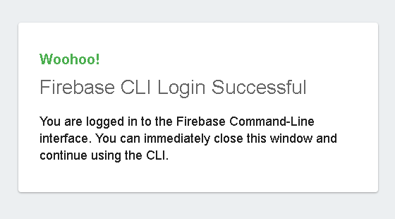

**Firebase init**

**// We choose the operation we want**

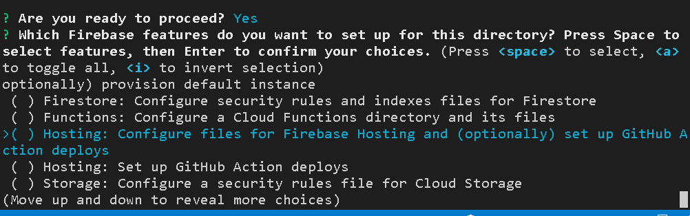



**firebase deploy**